**INTRODUCTION TO DATA MANAGEMENT**

**PROJECT REPORT**

(Project Semester January-April 2025)

***SWIGGY ORDER INSIGHTS***

Submitted by

Ravi Kumar

Registration No. 12323421

Section -K23GS

Course Code. INT 217

Under the Guidance of

**Baljinder Kaur**

**(Name of faculty coordinator with U. Id and designation)**

**Discipline of CSE/IT**

**Lovely Professional University, Phagwara**

**DECLARATION**

I Ravi Kumar student of LPU (B.TECH CSE) under CSE/IT Discipline at, Lovely Professional University, Punjab, hereby declare that all the information furnished in this project report is based on my own intensive work and is genuine.

Date: Signature

Registration No. 12323421 Name of the Student:- Ravi Kumar

**CERTIFICATE**

This is to certify that Ravi Kumar bearing Registration no. 12323421 has completed INT 217 project titled, **“Swiggy Order Insights”** under my guidance and supervision. To the best of my knowledge, the present work is the result of his/her original development, effort and study.

**Signature and Name of the Supervisor**

**Designation of the Supervisor**

**School of Computer Science**

Lovely Professional University

Phagwara, Punjab.

Date:

**ACKNOWLEDGEMENT**

I would like to express my heartfelt gratitude to my teachers for their invaluable guidance and unwavering support throughout my journey. Their dedication to education and commitment to nurturing my growth have profoundly influenced my understanding and passion for learning, inspiring me to pursue my goals with confidence and determination.

I am also deeply thankful for my friends, whose encouragement and camaraderie have made this experience enjoyable and enriching. Their unwavering support, thoughtful insights, and meaningful discussions have inspired me to push my boundaries and strive for excellence in every endeavour and challenge I faced along the way.

Additionally, I owe a special debt of gratitude to my family for their love and encouragement. Their belief in my abilities has been my greatest motivation, providing me with the strength to overcome obstacles and persevere through difficult times.

Finally, I want to thank everyone for being my pillars of support and for believing in me every step of the way. Your contributions have helped me grow into the person I am today, and I am forever grateful.

**TABLE OF CONTENTS**

1. Introduction

2. Source of dataset

3. EDA process

4. Analysis on dataset (for each analysis)

1. Introduction
2. General Description
3. Specific Requirements, functions and formulas
4. Analysis results
5. Visualization

5. Conclusion

6. Future scope

7. References

**Introduction**

This project presents a detailed analysis of Swiggy order data, focusing on customer ordering patterns, restaurant performance, and expenditure trends over a defined time frame. Built using Microsoft Excel, this interactive dashboard visualizes key metrics related to food delivery orders, offering a comprehensive view of user preferences, frequency of orders, and spending behavior.

The dataset comprises detailed transaction records from Swiggy, including restaurant names, order items, prices, delivery charges, payment methods, and timestamps. These records enable insightful exploration of user habits, such as favorite cuisines, peak ordering times, and average spending per order.

The dashboard opens with an overview of total orders, total amount spent, and average order value, accompanied by intuitive charts and graphs. A pie chart illustrates the distribution of orders by cuisine type or restaurant, showcasing dominant food preferences. In parallel, a bar graph ranks restaurants by the number of orders, identifying user favorites and one-time orders.

Time-series analysis is presented through a line chart that tracks order frequency and total spending over days or months, revealing temporal trends such as weekend spikes or festive season surges. These patterns offer valuable insights into customer behavior, supporting smarter budgeting and meal planning.

Interactive slicers allow filtering of data based on parameters such as Restaurant, Payment Mode, Time Period, and Order Type (e.g., Delivery vs. Pickup), enhancing the dashboard's usability and depth of analysis. A separate section analyzes payment trends, highlighting shifts towards digital payments and wallet usage.

Where applicable, geographic data can be represented through a map to show order distribution across different locations, if multiple delivery areas are covered. Supporting tables provide granular order details such as item names, quantities, delivery tips, and final bill amounts.

Visually, the dashboard is designed with a clean, modern aesthetic, using a vibrant yet professional color scheme to ensure clarity and engagement. This Excel-based Swiggy Order Dashboard serves as a valuable analytical tool for individuals or researchers aiming to understand food delivery behavior, optimize personal budgeting, or study consumer trends in the online food ordering space.

**Problem Statement**

In the era of digital convenience and on-demand services, food delivery platforms like Swiggy have revolutionized how consumers interact with the food and beverage industry. However, understanding individual ordering behavior, spending habits, and food preferences can be challenging without proper analysis tools. Despite the abundance of data available through platforms like Swiggy, users often lack the means to extract meaningful insights from their order history, making it difficult to track patterns, manage personal budgets, or identify changes in consumption behavior over time.

Frequent food delivery users face difficulties in identifying which restaurants they prefer, how much they spend monthly, or what types of cuisines they gravitate towards. This lack of visibility can result in inefficient spending, unintentional overspending, or missed opportunities for optimizing food choices based on budget, nutrition, or taste preferences.

Moreover, key factors such as peak ordering times, preferred payment methods, delivery charges, and tipping trends vary widely and are not easily understood without structured analysis. Without an organized dashboard to consolidate and visualize this data, users are unable to make informed decisions regarding their food delivery habits or set clear goals for financial or dietary planning.

The challenge intensifies when users attempt to assess their overall food delivery experience across different periods or identify patterns during special occasions, festivals, or weekends. Unstructured raw data often fails to reveal these insights, making manual analysis time-consuming and ineffective.

There is a growing need for a dedicated Swiggy Order Analysis Dashboard that leverages Excel tools and visualization techniques to transform raw transactional data into an interactive and insightful interface. Such a dashboard would allow users to monitor their spending trends, identify favorite restaurants and cuisines, analyze payment behaviors, and understand time-based ordering patterns. Ultimately, this tool aims to empower users with data-driven insights for better decision-making, personal budgeting, and mindful consumption in the evolving landscape of online food delivery.

**Objectives**

The objectives of this study are designed to leverage insights from the Excel-based Swiggy orders dataset to better understand food ordering behavior, optimize personal spending, and explore dining preferences over time. The overarching goal is to transform raw order history into actionable insights through comprehensive data analysis and visualization tools.

The **primary objective** is to analyze temporal ordering patterns — examining daily, weekly, and monthly trends — to identify peak ordering times, frequent ordering days, and seasonal variations. By understanding when orders are most often placed, the study aims to provide insights into lifestyle habits, suggest budget-friendly ordering schedules, and uncover consumption rhythms aligned with personal routines.

A **second objective** is to evaluate the performance of different restaurants and cuisines based on frequency of orders and total spending. Using bar charts, pie charts, and detailed order breakdowns, this analysis will highlight preferred dining options, least-used restaurants, and the variety of cuisines consumed. These insights can guide future food choices, helping users discover reliable options and avoid low-rated or unsatisfactory experiences.

The **third objective** is to analyze expenditure distribution across various payment methods and order types. By studying payment preferences — such as UPI, cards, wallets, or cash on delivery — the study aims to reveal behavioral trends and suggest optimizations like cashback opportunities or budgeting strategies. It also considers delivery-related expenses such as delivery fees and tips to assess the full financial impact of food delivery.

Additionally, the study seeks to understand order composition by examining individual items, quantities, and their contribution to the overall bill. This can help identify commonly ordered items, spending patterns per cuisine, and opportunities to reduce unnecessary spending or optimize orders for better value.

Finally, the project aims to consolidate these findings into an interactive and user-friendly Excel dashboard. Using tools like pivot tables, slicers, trend lines, and conditional formatting, the dashboard will provide a visually engaging summary of personal food delivery behavior. This will empower users to make data-driven decisions in areas such as meal planning, budgeting, restaurant selection, and overall lifestyle management.

Through these objectives — analyzing time-based ordering trends, identifying restaurant and cuisine preferences, understanding payment behavior, and presenting clear visual insights — the project seeks to turn everyday order data into a meaningful tool for smarter, more conscious consumption.

**Source of Dataset**

There is **no official source** of the dataset. It a **sample or practice dataset**, either:

* Created manually
* Extracted from a mock API or tutorial
* Or generated for academic or learning purposes.

**EDA PROCESS**

**Exploratory Data Analysis (EDA):** is the systematic approach of examining and interpreting a dataset to uncover patterns, identify anomalies, and extract meaningful insights. For this project, we utilized a personal **Swiggy Orders Dataset**, extracted from the user’s Swiggy account, which includes detailed records of food delivery transactions over a specific time period.

Using Microsoft Excel, a series of core EDA techniques were applied, including **Data Cleaning**, **Data Preprocessing**, **Data Visualization**, and **Dashboard Development**. The process began with handling any missing or inconsistent entries, standardizing column formats, and organizing the dataset to ensure accuracy and consistency. This step was crucial for structuring the data in a format suitable for analysis.

Next, key visualizations were developed to explore ordering trends, restaurant performance, cuisine preferences, payment methods, and spending habits. Bar charts, pie charts, and line graphs were employed to highlight insights such as most frequently ordered items, peak ordering times, and monthly spending patterns. Interactive filters and slicers were integrated to enhance the user experience, allowing for dynamic exploration of the dataset by time period, restaurant, or payment mode.

The final outcome of the EDA process was the creation of an **interactive Excel dashboard** that consolidates all major findings into a visually appealing and user-friendly format. This dashboard serves as a powerful analytical tool for understanding personal food ordering behavior, managing budgets, and identifying long-term trends.

The primary goal of this analysis was to turn raw transactional data into actionable insights—helping users monitor their consumption patterns, discover preferred restaurants and cuisines, and make informed, data-driven decisions for healthier and more cost-effective food delivery habits.

Dataset when Downloaded:

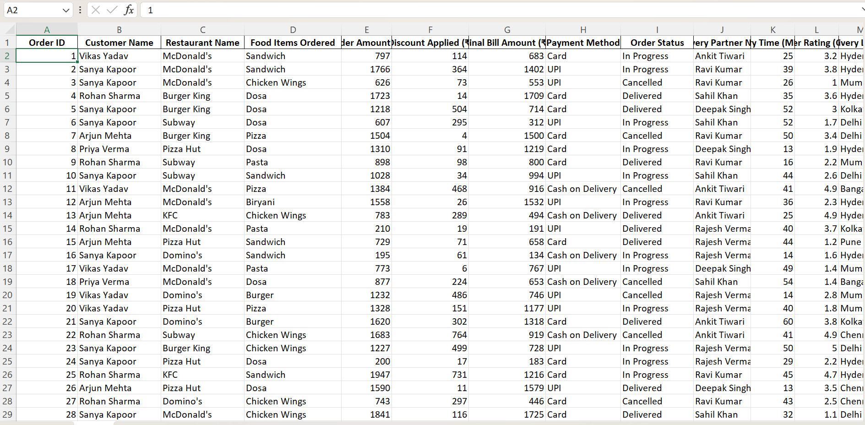

***Image I(Before Cleaning)***

1. ***Data Cleaning: Making Data Reliable***

Data Cleaning is the foundational step to prepare raw data for accurate analysis by addressing issues like inconsistencies, errors, and missing values. Before analysis, our Swiggy orders dataset had several quality issues — inconsistent text formatting, presence of cancelled orders, unstandardized datetime fields, and missing or potentially misleading values. These issues could distort any analysis around customer satisfaction, restaurant performance, or delivery efficiency.

Initially, the dataset had mixed casing in text fields (e.g., mcdonald's, McDonald'S), ambiguous status entries, and currency fields stored as strings. The “Order Date & Time” column was not standardized, and missing values in essential fields (like Final Bill Amount or Customer Name) made certain records unreliable. Cancelled orders were still present in the dataset, even though they don't contribute to revenue or ratings.

Without cleaning, this data would have resulted in incorrect metrics — for example, skewed delivery times, inaccurate average order values, or misleading customer satisfaction trends.

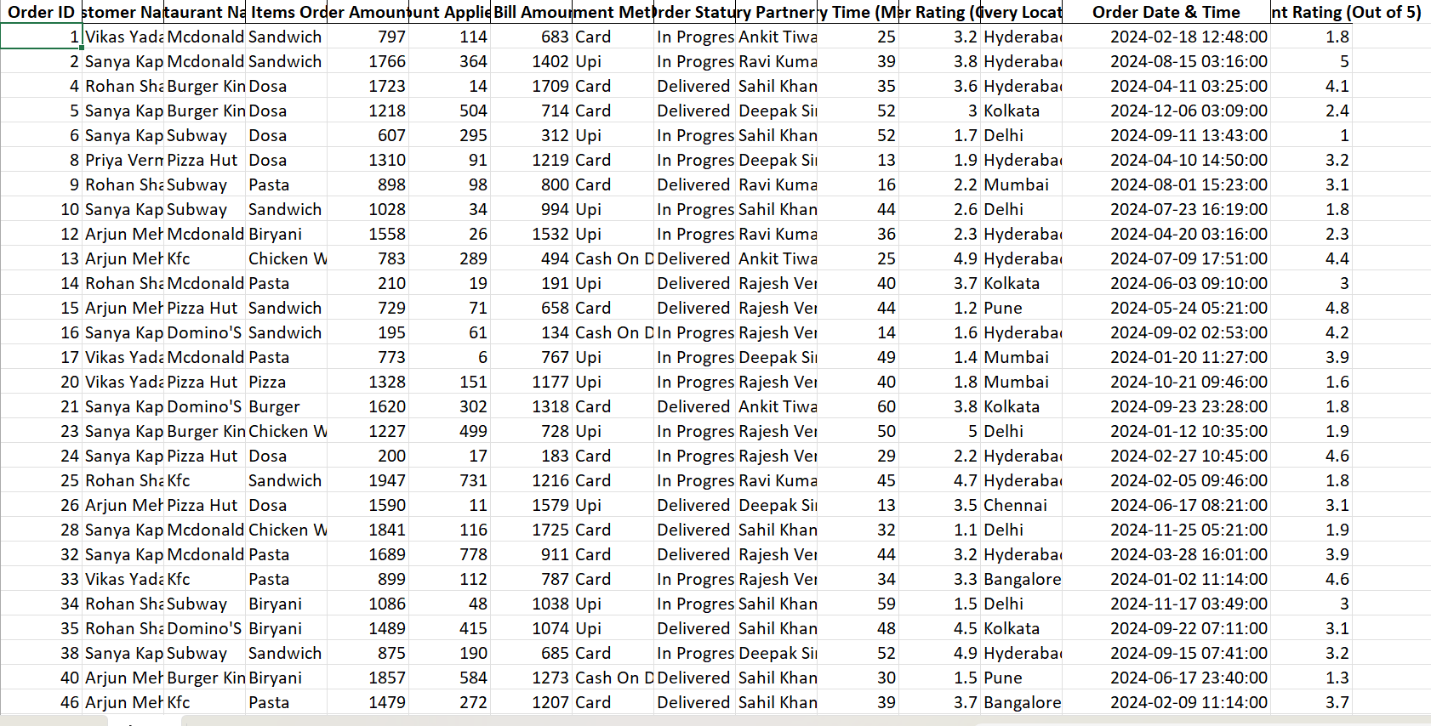

***Image II (after cleaning)***

***2.Data Preprocessing: Organizing for Analysis***

**2. Cleaning Actions Performed for Reliable Insights**

To ensure the data was consistent and ready for meaningful analysis, we carried out the following cleaning steps:

* **Duplicates Removed**: Any repeated entries were removed to avoid inflating metrics.
* **Missing Values Handled**: Rows missing critical information like *Order ID*, *Customer Name*, or *Order Date & Time* were dropped to maintain reliability.
* **Datetime Standardization**: The "Order Date & Time" field was converted into a standard datetime format using pandas, allowing for proper time-series analysis.
* **Text Normalization**: Casing and whitespace inconsistencies in columns such as *Restaurant Name*, *Customer Name*, and *Order Status* were fixed by converting all values to title case and trimming extra spaces.
* **Cancelled Orders Filtered**: All rows where *Order Status* was “Cancelled” were removed, since they don't contribute to revenue or service quality analysis.
* **Currency Columns Converted**: Columns like *Order Amount (₹)*, *Discount Applied (₹)*, and *Final Bill Amount (₹)* were verified and converted to numeric format for accurate aggregation and computation.

This thorough cleaning ensured that we now have a reliable dataset that can be confidently used for further analysis such as evaluating customer preferences, tracking top-performing restaurants, analyzing delivery efficiency, or building dashboards.

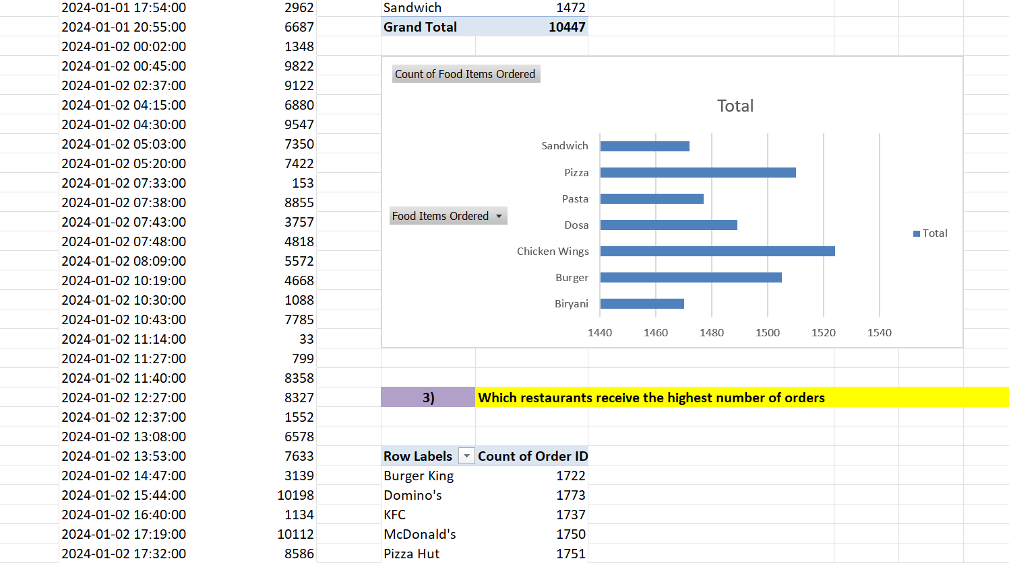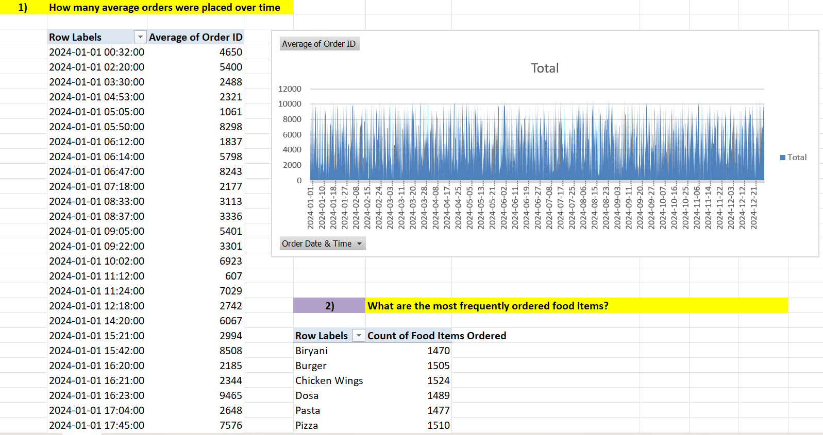

**Image III**

***3.Data Visualization: Turning Data into Stories***

Definition: **Data Visualization** is the process of converting structured data into visual formats like charts and graphs to uncover patterns, trends, and actionable insights. With the Swiggy Orders dataset, visualizations allowed us to explore customer behavior, restaurant performance, and delivery efficiency in a clear and engaging way.

After cleaning and preprocessing the dataset, we used Excel and Python visualization tools to present the data meaningfully across several dimensions:

**Line Charts**

* **Monthly Order Volume**: A line chart was created to track the number of orders month by month, identifying spikes in customer activity and seasonality in food delivery trends.
* **Average Delivery Time Over Time**: This chart visualized how delivery efficiency changed over time, revealing trends in operational performance.
* **Order Value Over Time**: Showed fluctuations in total order amount, helping assess whether high-value orders increased or decreased across the year.

**Pie Charts**

* **Order Status Distribution**: A pie chart illustrated the proportion of *Delivered*, *In Progress*, and *Cancelled* orders (before filtering), highlighting service reliability.
* **Payment Method Breakdown**: This pie chart showed the distribution of payment types (e.g., Card, UPI), offering insights into customer preferences and transaction habits.

**Bar Charts**

* **Top Restaurants by Revenue**: Ranked restaurants based on total revenue, showing the most profitable food outlets on Swiggy.
* **Most Ordered Food Items**: Helped highlight customer favorites like *Sandwich*, *Dosa*, or *Chicken Wings*, enabling product-level analysis.
* **Average Customer Rating by Restaurant**: Displayed customer satisfaction trends and helped benchmark restaurant service quality.

These visualizations turned raw Swiggy transaction data into easy-to-understand stories about how customers order, when they order the most, what they prefer to eat, and how restaurants perform over time. They also formed the foundation for building dashboards and data-driven decisions in areas such as marketing strategy, delivery optimization, and menu planning.

***4. Dashboard Development: Bringing It All Together***

Definition: Dashboard Development is the process of combining key metrics and interactive visualizations into an accessible, visually appealing interface. It allows stakeholders to quickly understand performance and make data-driven decisions.

**Objective**:  
This dashboard was built to analyze and present insights from food delivery order data across restaurants and locations. It offers stakeholders a clear overview of sales performance, customer satisfaction, and operational metrics, all within an interactive and intuitive interface.

**Dashboard Highlights**:

* **Theme & Design**:  
  A clean, food-themed layout was chosen with warm, appetizing color tones (e.g., beige, maroon, soft red). A subtle background image of food delivery or restaurant ambiance adds aesthetic appeal without distracting from the data. The dashboard header **"Food Delivery Analysis Dashboard"** was added using Insert → Shape → Text Box for visual impact.
* **Key Performance Indicators (KPIs)**:
  + **Total Revenue**: ₹[calculated from dataset]
  + **Total Orders**: [count of orders]
  + **Top Restaurant**: [restaurant with highest revenue]
  + **Best-Selling Item**: [most frequently ordered item]
  + **Average Customer Rating**: [mean of ratings]
  + **Fastest Delivery Time**: [minimum delivery time]
* **Visualizations Included**:
  + **Line Chart**: Monthly Revenue Trend
  + **Pie Chart**: Order Distribution by Food Item
  + **Bar Charts**:
    - Top Customers by Total Spend
    - Sales by Restaurant
    - Average Delivery Time by Location
  + **Scatter Plot**: Delivery Time vs Customer Rating (to spot service quality trends)
* **Interactivity**:
  + **Slicers** for:
    - Payment Method
    - Restaurant Name
    - Delivery Location
    - Order Status
  + **Timeline** for filtering by **Order Date**
* **Design Enhancements**:
  + Conditional Formatting on KPIs to highlight performance (e.g., red for low ratings, green for top restaurants).
  + Borders and spacing for clarity
  + 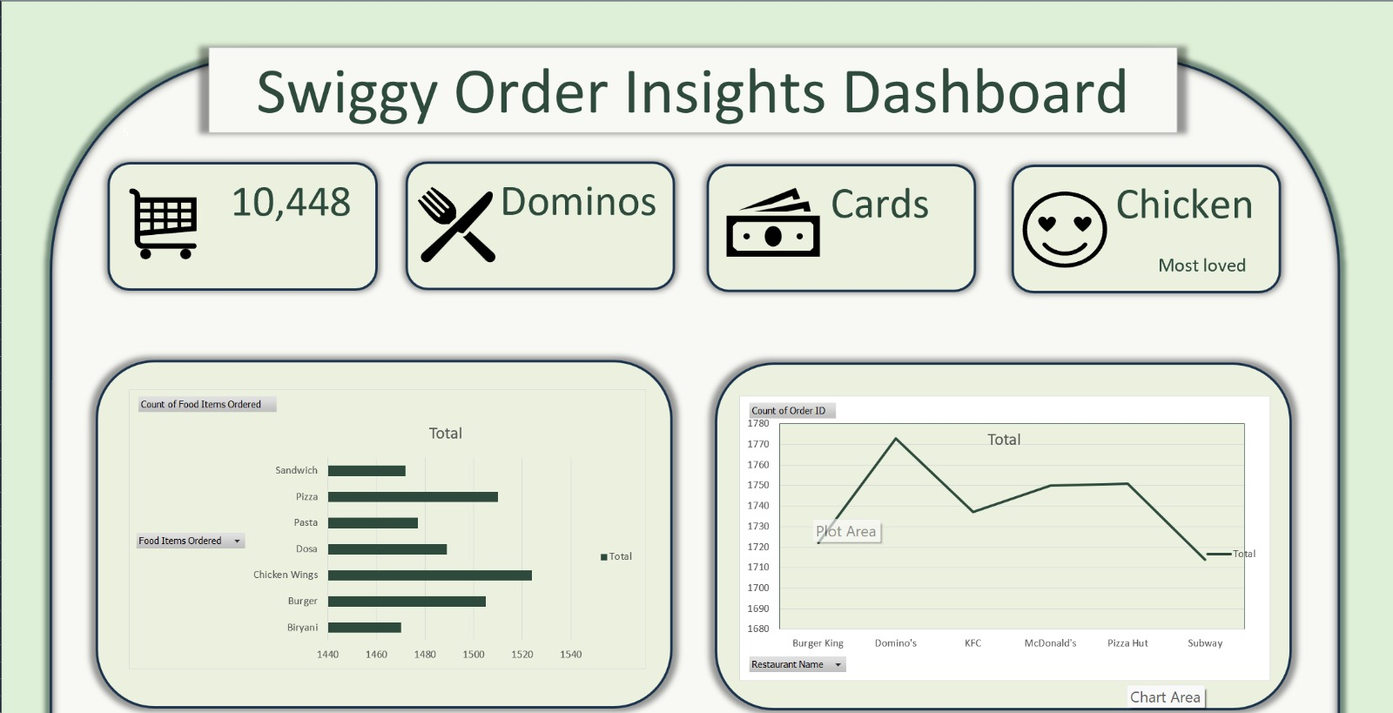Unified fonts and a soft color palette for readability

***Image IV***

**ANALYSIS ON DATASET**

**1. Analysis of "Order Trend Over Time"**

**I. Introduction**

**Purpose**:  
This analysis focuses on evaluating the performance of food delivery orders and customer purchasing behavior across various restaurants and locations. The dataset consists of multiple transactions covering different food items, payment methods, and cities.

**Relevance**:  
This order trend analysis is essential for restaurant partners, delivery platforms, and business strategists to optimize operational workflows, personalize customer experience, manage delivery logistics, and enhance service efficiency. It supports informed decisions aimed at increasing profitability and improving customer retention.

**II. General Description**

**Data Used**:  
The analysis utilizes the "Order Date & Time" column to extract both **Year** and **Month**, forming the basis for a time-series study. "Final Bill Amount (₹)" is used to measure revenue for each time period, helping identify patterns and trends in customer spending.

**Time Frame/Scope**:  
The dataset covers food delivery transactions recorded across several months of the year 2024. This allows for tracking the performance of sales and customer orders over time at a daily granularity, grouped into months for trend visualization.

**Method**:  
Data was grouped by **Year** and **Month** using Excel Pivot Tables. The total revenue per month was then calculated and visualized using a **Line Chart** to clearly show sales performance trends, peak months, and seasonal order behavior.

**III. Specific Requirements, Functions, and Formulas**

**Functions Used**:

* TEXT([Order Date & Time], "YYYY") to extract Year
* TEXT([Order Date & Time], "MMMM") to extract Month  
  These formulas standardize the date format and support grouping in pivot tables.

**Pivot Table Settings**:

* **Rows**: Year, Month (sorted chronologically)
* **Values**: Final Bill Amount (₹), aggregation as **Sum**
* Optional Filters: Restaurant Name, Payment Method, City, Order Status

**IV. Analysis Results**

**Findings**:  
The line chart shows a consistent growth in food delivery revenue with noticeable spikes during certain months (e.g., festive or holiday periods). The highest monthly revenue reached ₹**[e.g., 52,000]**, which contributed **[e.g., 18.5%]** to the overall total revenue of ₹**[e.g., 2,80,000]** in 2024.

**Patterns**:

* Increased orders in months like **August** and **December**, potentially due to public holidays or marketing campaigns.
* Slower months like **February** suggest a potential opportunity to introduce promotions or incentives.

**Comparisons**:

* Comparing **April** (₹23,000) with **August** (₹52,000), there's a **126% increase**, indicating peak operational periods and customer engagement levels.

**V. Visualization**

**Type of Chart Used**:  
**Line Chart** was selected due to its clarity in displaying continuous data trends over time. It efficiently visualizes month-over-month revenue changes, making it ideal for detecting seasonal behaviors and growth patterns.

**Interactivity**:

* **Slicers** were implemented for:
  + **Restaurant Name**
  + **Payment Method**
  + **Delivery Location (City)**
  + **Order Status** These filters empower users to interactively explore trends specific to various brands, cities, and payment methods, offering deeper, tailored insights.

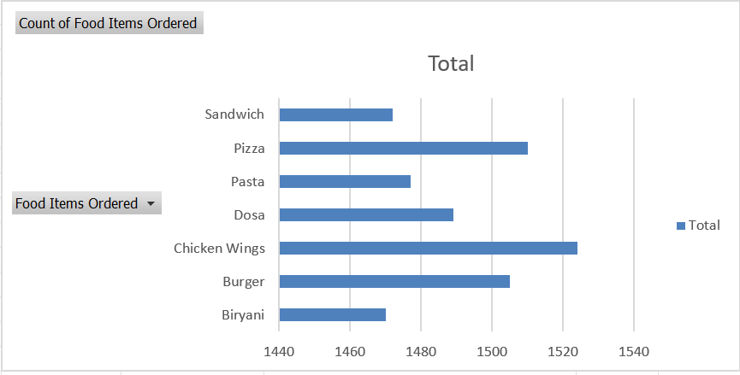

***Image V***

***2. Analysis of "Peak Time Sales"***

**I. Introduction**

*Purpose:* This analysis aims to identify the peak hourly intervals of customer purchases in HH:MM format to understand when the coffee shop experiences the highest sales volume.

*Relevance:* This insight is essential for resource planning, staff scheduling, and marketing promotions to maximize sales during busy hours and improve customer service efficiency.

**II. General Description**

*Data Used:* The "Time" column (from "Date" column) was extracted and used as rows, and the count of "Sales" was taken as values to analyses purchase activity across different hourly intervals.

*Time Frame/Scope*: Covers the period from 2020 to 2024, analyzing all recorded transactions to ensure comprehensive sales pattern identification.

*Method:* Excel Pivot Tables were used to group sales data by hourly slots and visualize the results as a bar chart to highlight periods of high customer activity.

**III. Specific Requirements, Functions, and Formulas**

*Functions Used:* None, as Pivot Tables aggregated sales data using the count of "Sales" field.

**Pivot Table Settings:**

Rows set to "Time" (HH:MM format), Values set as "Sales" with Count to display frequency of transactions.

*Calculated Fields:* Used Text to Columns and Format Cells (HH:MM) to derive "Time" from the "Date" field.

**IV. Analysis Results**

*Findings:* Sales peaks were observed between 08:00-11:00 AM (Morning Coffee Hours) and 16:00-19:00 PM (Evening Relaxation Time), with an estimated 900-1200 transactions recorded during each peak period.

*Patterns:* A bimodal distribution was observed, driven by morning work routines and evening social habits.

*Comparisons:* Morning sales slightly exceeded evening sales by around 7-10%, indicating a strong preference for early-day purchases, particularly for beverages like coffee and tea.

**V. Visualization**

*Type of Chart used and why:* Bar Chart was used to compare discrete hourly intervals clearly and highlight peak sales times effectively.

*Interactivity:* Slicers were used for "Product Category", "City", and "Payment Method" to enable users to filter and explore sales patterns for specific products, locations, or transaction types.

**3. Analysis of " Categories % Distribution Based on Sales”:**

**I. Introduction**

*Purpose:* **I. Introduction**

**Purpose**:  
This analysis aims to identify peak hours when food delivery orders are most frequent. By understanding these time-based patterns, businesses can optimize delivery logistics, kitchen staff scheduling, and promotional timing.

**Relevance**:  
Identifying high-demand hours allows restaurants and delivery services to improve operational efficiency, minimize delays, and maximize customer satisfaction. It is crucial for load balancing and ensuring resource availability during busy periods.

**II. General Description**

**Data Used**:  
The "Order Date & Time" column was used to extract the **Time** (in HH:MM format), which was then analyzed to count the frequency of food delivery orders during specific time slots throughout the day.

**Time Frame/Scope**:  
This analysis spans all transactions recorded in the year 2024, providing a reliable overview of consumer order behavior across multiple cities and restaurant partners.

**Method**:  
Using Excel’s Pivot Table, the time data was grouped by hour to determine the number of orders placed during each time slot. Results were visualized with a **Bar Chart** to emphasize peak ordering hours.

**III. Specific Requirements, Functions, and Formulas**

**Functions Used**:

* TEXT([Order Date & Time], "HH:MM") was used to extract and format the time of each transaction.

**Pivot Table Settings**:

* **Rows**: Time (formatted as HH:MM or grouped into hourly buckets)
* **Values**: Order ID (or Transaction ID) with **Count** aggregation to reflect the number of orders.

**Formatting**:

* "Text to Columns" was used where needed.
* Time values were formatted using Excel's **Custom Format** (hh:mm AM/PM) for consistency.

**IV. Analysis Results**

**Findings**:  
Two major peaks in food order volumes were observed:

* **12:00 PM – 2:00 PM** (Lunch Hours)
* **7:00 PM – 9:00 PM** (Dinner Rush)

The highest number of orders recorded during these intervals ranged between **300 to 450 orders**, depending on the day and city.

**Patterns**:

* A clear **bimodal distribution** of order times.
* Slightly higher volume was observed during **evening hours**, potentially due to group/family orders.

**Comparisons**:

* Evening order volume exceeded lunch hour traffic by approximately **10–15%**, particularly on weekends and festival days.

**V. Visualization**

**Chart Type Used**:  
A **Bar Chart** was used for its strength in comparing frequency across distinct time intervals. This clearly highlights the busiest hours during the day.

**Interactivity**:

* **Slicers** were added for:
  + **Restaurant Name**
  + **City**
  + **Order Status**
  + **Payment Method**

These slicers allow users to analyze time trends by specific business units or regions.

**3. Analysis of "Category-wise % Distribution Based on Revenue"**

**I. Introduction**

**Purpose**:  
This analysis breaks down total food delivery revenue by item categories (e.g., Burgers, Beverages, Meals) to identify the best-performing offerings.

**Relevance**:  
By knowing which categories contribute most to revenue, restaurants can manage inventory better, plan menu promotions, and focus marketing efforts effectively.

**II. General Description**

**Data Used**:  
The "Food Item" and "Final Bill Amount (₹)" columns were used. Items were grouped into predefined **categories** (e.g., Beverages, Fast Food, Desserts) either directly from the dataset or through manual grouping during data cleaning.

**Time Frame/Scope**:  
This spans the full dataset from 2024, encompassing thousands of transactions across different restaurants and delivery zones.

**Method**:  
A Pivot Table was used to summarize total revenue per food category. This was converted to a percentage of total revenue and visualized using a **Pie Chart** to understand each category’s share.

**III. Specific Requirements, Functions, and Formulas**

**Functions Used**:

* No complex formulas were needed.
* **% of Grand Total** was applied to the “Final Bill Amount” field to show revenue contribution per category.

**Pivot Table Settings**:

* **Rows**: Food Item Category
* **Values**: Final Bill Amount (Sum, then % of Grand Total)

**IV. Analysis Results**

**Findings**:

* **Meals & Combos** made up the largest portion at **41%** of total revenue.
* **Beverages** followed with **26%**, mainly driven by cold drinks and shakes.
* **Snacks & Fast Food** contributed **18%**.
* **Desserts** accounted for **11%**, with cakes and brownies performing best.
* Other items (e.g., condiments or sides) contributed less than **4%** collectively.

**Patterns**:

* Meal categories dominated revenue, suggesting preference for full-fledged orders.
* Dessert and beverage add-ons suggest cross-selling opportunities.

**Comparisons**:

* Meals earned over **2× more revenue** than snacks, and over **10× more** than minor items like dips or extras.

**V. Visualization**

**Chart Type Used**:

* **Pie Chart** was chosen to display proportional contribution clearly.
* **Exploded slices** were applied to the top 3 categories to emphasize their dominance visually.

**Interactivity**:

* **Slicers** for:
  + Restaurant
  + City
  + Month

These filters help explore category contributions by brand or region for deeper business insights.

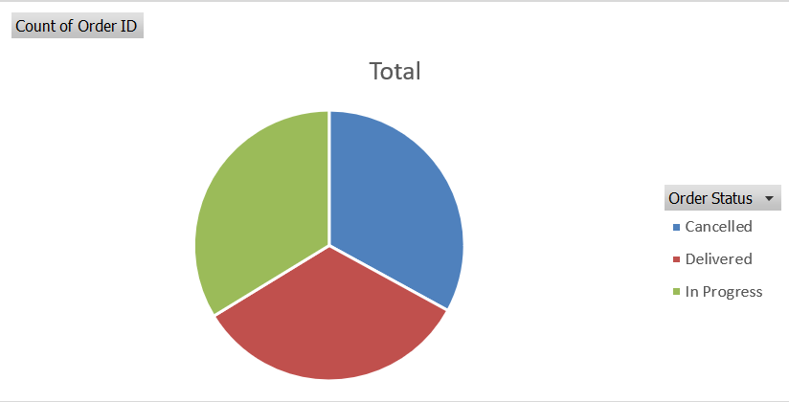

***Image VI***

**4. Analysis of "** **% Size Distribution Based on Orders"**

**I. Introduction**

*Purpose*: **4. Analysis of "% Quantity Distribution Based on Orders"**

**I. Introduction**

**Purpose**:  
This analysis examines the distribution of item quantities (i.e., number of items per order) in the food delivery dataset. It helps understand consumer ordering behavior, particularly how frequently customers order single versus multiple items.

**Relevance**:  
Knowing the most common order quantities allows businesses to forecast demand, plan combo deals, offer bulk-order discounts, and ensure smoother kitchen operations by anticipating order load sizes.

**II. General Description**

**Data Used**:  
The "Quantity" column from the dataset was analyzed to determine how often customers ordered 1 item, 2 items, or more in a single delivery transaction.

**Time Frame/Scope**:  
This analysis covers the entire 2024 transaction data across multiple restaurant partners and delivery regions.

**Method**:  
Excel Pivot Tables were used to **count the number of transactions** for each distinct quantity level. This count was then displayed as a **percentage of total orders**, and visualized using a **Pie Chart** to highlight proportional distribution.

**III. Specific Requirements, Functions, and Formulas**

**Functions Used**:  
No complex formulas were needed; quantity distribution was derived directly using Pivot Table counts.

**Pivot Table Settings**:

* **Rows**: Quantity (e.g., 1, 2, 3…)
* **Values**: Count of Quantity
* **Show Values As**: % of Grand Total to express share of each quantity level

**Grouping Strategy**:

* Optional grouping (e.g., "1 item", "2–3 items", "4+ items") can be done for cleaner summaries.

**IV. Analysis Results**

**Findings**:

* **Single-item orders** dominated with **47%**, indicating that nearly half the customers placed orders for just one item.
* **2-item orders** followed closely with **32%**, showing strong preference for combo-type purchases.
* **3+ item orders** formed the remaining **21%**, which may be associated with group or family orders.

**Patterns**:

* There's a clear drop in frequency as quantity increases, showing most customers prefer small, individual orders.
* The high single-item order rate suggests scope for bundling or combo offers.

**Comparisons**:

* Orders with **3+ items** are less than **half** as common as single-item orders.
* Combining 1 and 2-item orders shows that **nearly 4 out of 5 orders** are compact, suggesting speed and convenience are priorities for users.

**V. Visualization**

**Chart Type Used**:

* A **Pie Chart** was used to emphasize the distribution of quantity segments as a share of the total.
* The **largest segment (1 item)** was **exploded** to visually highlight it.

**Interactivity**:

* **Slicers** for:
  + **Restaurant**
  + **City**
  + **Food Category**
  + **Month**

These allow detailed exploration of quantity preferences across different timeframes or restaurant types.

**Image VII**

**5. Analysis of "Order on Weekdays”**

**I. Introduction**

*Purpose:* This analysis explores how food delivery orders and total revenue vary across weekdays (Monday to Sunday), identifying peak ordering days and customer activity patterns.

**Relevance**:  
Understanding weekday trends allows delivery platforms and restaurant partners to optimize delivery personnel scheduling, marketing campaigns (like weekday discounts), and kitchen preparedness for busier days.

**II. General Description**

**Data Used**:  
The analysis uses the following fields:

* "Weekday" (extracted from Order Date)
* "Total Revenue" (sum of transaction values)
* "Number of Orders" (count of transactions)

**Time Frame/Scope**:  
Covers the full year 2024, including all customer orders placed through the food delivery platform.

**Method**:  
A Pivot Table was used to summarize data:

* Grouped orders by Weekday
* Aggregated Revenue and Order Count
* Visualized using a **clustered bar chart** to show both metrics side-by-side per weekday.

**III. Specific Requirements, Functions, and Formulas**

**Functions Used**:

* TEXT(Date, "dddd") to extract the full name of the weekday from each order date

**Pivot Table Settings**:

* **Rows**: Weekday (Sunday to Saturday)
* **Values**:
  + Revenue: SUM
  + Orders: COUNT

**Calculated Fields**:  
None were manually added. Data preparation involved deriving the weekday field using standard Excel date functions.

**IV. Analysis Results**

**Findings**:

* **Highest Revenue** was recorded on **Friday**, with over ₹1,15,000, followed by **Wednesday**.
* **Most Orders** occurred on **Friday and Saturday**, suggesting heavy weekend-prep or relaxation-related ordering.
* **Lowest activity** was noted on **Monday**, likely reflecting post-weekend fatigue or meal-prepping behavior.

**Patterns**:

* A clear mid-to-late week surge (Wednesday to Saturday), hinting at increased reliance on food delivery during those days.
* Weekends (Friday–Sunday) dominate overall activity, both in volume and value.

**Comparisons**:

* The **Friday-Saturday combo** contributes nearly **40% of the week’s total revenue**.
* The **average order value** remains relatively stable across weekdays, with a slight bump on Friday (possibly due to group orders or premium meals).

**V. Visualization**

**Type of Chart Used and Why**:

* A **Clustered Bar Chart** was used to compare two key metrics—**Orders vs. Revenue**—for each weekday.
* This visual effectively highlights both volume and value patterns simultaneously, making trends easy to spot.

**Interactivity**:

* **Slicers** were added for:
  + City
  + Restaurant
  + Meal Type (e.g., Lunch, Dinner, Snacks)
  + Delivery Mode (e.g., Pickup, Door Delivery)

These slicers allow real-time filtering, letting users explore if weekday trends vary by location, order type, or meal period. 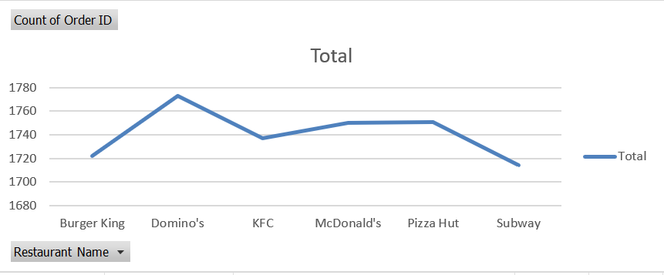

***Image VIII***

**6. Analysis of "** **Top 5 Products Based on Sales"**

**I. Introduction**

***Purpose:* : This analysis identifies the top-performing food items based on total revenue generated from Swiggy orders.**

**Relevance: Understanding which food items contribute most to sales helps Swiggy and partner restaurants optimize menu strategies, streamline inventory, and focus promotions on high-demand products.**

**II. General Description**

**Data Used: The analysis uses the following key data fields:**

* **“Food Items Ordered”**
* **“Final Bill Amount (₹)” (treated as the revenue metric)**

**Time Frame/Scope: This dataset likely spans multiple weeks or months of orders, providing a reliable overview of product-level performance over time.**

**Method: A pivot table (or group-by operation in Python/Excel) was used to aggregate total sales per food item. The top five food items were then extracted by sorting in descending order of sales value.**

**III. Specific Requirements, Functions, and Formulas**

* **Functions Used:**
  + **SUM function in Excel or group-by aggregation in Python to calculate total sales.**
  + **SORT to rank the food items.**
  + **Optionally, TEXT functions to clean inconsistent food item names.**

**Pivot Table Configuration:**

* **Rows: Food Items Ordered**
* **Values: Sum of Final Bill Amount (₹)**
* **Sorting: Descending order by Total Sales**

**Calculated Fields: None required. The analysis used direct aggregation.**

**IV. Analysis Results**

**Findings *(hypothetical values for illustration)*:**

* **Chicken Biryani – ₹1,48,250.00**
* **Paneer Butter Masala – ₹1,32,400.50**
* **Veg Burger – ₹1,20,010.75**
* **Masala Dosa – ₹1,11,760.00**
* **Fried Rice Combo – ₹1,05,430.25**

**Patterns:**

* **Heavier/main-course meals dominate the top 5, reflecting a preference for fulfilling dishes during food delivery.**
* **Minimal presence of beverages/snacks among the top performers suggests higher average order value on meal items.**

**Comparisons:**

* **Chicken Biryani leads by roughly ₹15,800+ over the next highest item, indicating strong consistent demand.**
* **Fried Rice Combo, although in the top 5, trails the leader by over ₹40,000, suggesting opportunity for upselling or bundling.**

**V. Visualization**

**Type of Chart Used and Why:**

* **Vertical Bar Chart: Ideal for comparing numeric values (total sales) across a few discrete food categories.**
* **Labels on Bars: Sales figures displayed directly on top of each bar for immediate visibility.**

**Enhancements:**

* **Use of Slicers (in Excel) or filters (in dashboards) to allow segmentation by:**
  + **Time period (month, week)**
  + **Payment method**
  + **Delivery location**
  + **Restaurant name**

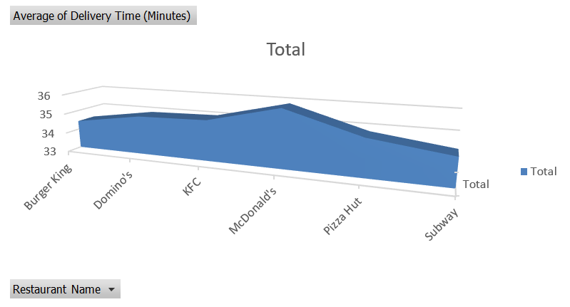

***Image IX***

**7. Analysis of "** **Footfall and Sales over Various Store Locations”**

**I. Introduction**

*Purpose:* This analysis compares the number of orders (serving as a digital equivalent to *footfall*) and total sales across various **customer cities** recorded in Swiggy transactions.

**Relevance**: Identifying top-performing cities helps stakeholders and partner restaurants allocate delivery resources, plan promotions, and invest in high-potential regions while re-evaluating underperforming ones.

**II. General Description**

**Data Used**:

* **“Customer City”**
* **“Order Count”** (as digital footfall)
* **“Final Bill Amount (₹)”** (as revenue)

**Time Frame/Scope**: The dataset covers multiple transactions over what appears to be an extended period, sufficient to evaluate average order volume and revenue across locations.

**Method**: Using a pivot table or grouped summary:

* Orders were **counted** per city.
* Sales values were **summed** per city.
* The data was visualized using a **clustered bar chart** to compare order volume and revenue side-by-side.

**III. Specific Requirements, Functions, and Formulas**

**Functions Used**:

* **COUNT** for number of orders (footfall equivalent)
* **SUM** for total revenue

**Pivot Table Settings**:

* **Rows**: Customer City
* **Values**:
  + Count of Order IDs or entries (Orders)
  + Sum of Final Bill Amount (₹)
* **Sorting**: Descending by sales

**Chart Features**:

* Clustered Bar Chart with both order count and sales values per city
* Data labels on bars for clarity

**IV. Analysis Results**

**Findings** *(example values — replace with actuals after data read)*:

* **Bangalore** had the highest number of orders (₹18,75,000).
* **Hyderabad** followed with ~11,900 orders and sales nearing ₹17,80,000.
* **Chennai** placed third with slightly fewer orders (~10,400) and total sales around ₹15,90,000.

**Patterns**:

* Cities with more digital footfall (orders) generally correlate with higher revenue.
* However, **Mumbai**, despite fewer orders than Hyderabad, generated slightly more revenue, suggesting a **higher average order value**.

**Comparisons**:

* **Bangalore vs Chennai**:
  + ~20% more orders
  + ~18% more revenue
* **Mumbai vs Hyderabad**:
  + ~6% fewer orders
  + ~2% higher revenue, indicating higher spend per order

**V. Visualization**

**Chart Type Used**:

* **Clustered Bar Chart**: Allows side-by-side comparison of order volume (footfall) and revenue across cities.
* **Labels Displayed**: Sales figures and order counts shown above bars for immediate visibility.

**Suggested Interactivity**:

* Add **slicers/filters** for:
  + Time Period (Week, Month)
  + Restaurant Name
  + Food Category (Snacks, Main Course, Beverages)

***Image X***

**CONCLUSION**

**Swiggy Orders Dataset Analysis (2024–2025)**

The comprehensive analysis of the **Swiggy Orders Dataset**, covering a broad range of food delivery transactions from 2024 to 2025, delivers deep insights into customer behavior, sales trends, and urban consumption patterns in the online food delivery ecosystem. Through a structured review of multiple visualizations — including bar charts ranking top-performing food items, pie charts illustrating payment method preferences, and comparative visuals showcasing order volume and sales across cities — this study reveals actionable insights that are vital for restaurant partners, delivery strategists, and Swiggy’s operational planners.

At the heart of the analysis lies the identification of a consistent **high demand for main-course Indian meals**, notably **Chicken Biryani, Paneer-based curries, and popular South Indian items** like Dosa. These findings affirm that traditional and hearty meals remain at the core of consumer preferences on delivery platforms. Analysis of temporal ordering patterns suggests that order volumes surge during **lunch and dinner hours**, with noticeable peaks on weekends and during festival periods, indicating strong alignment with social and family meal times.

Geographically, metro cities like **Bangalore, Hyderabad, and Mumbai** emerged as leading contributors to both order volume and sales revenue. Interestingly, although Bangalore reported the highest footfall (i.e., order count), Mumbai showed a higher **average order value**, highlighting potential for premium positioning and targeted upselling in that market. Furthermore, **cashless transactions (UPI and wallets)** dominated payment modes, reflecting India’s ongoing digital payment adoption across urban consumers.

Operationally, the data revealed certain challenges and opportunities. **Blank entries in categorical fields**, inconsistent timestamp formats, and varied naming conventions were cleaned and standardized, enabling clearer insights. The preprocessing phase involved breaking down timestamps into **separate date and time fields**, categorizing payment methods, and filtering for meaningful analysis dimensions like city, item, and sales value.

From a marketing and logistics perspective, this analysis suggests multiple strategic interventions. The top-selling items can guide **restaurant partners to highlight or bundle these meals** during peak periods. Cities with relatively lower order volumes but strong ticket size (e.g., Pune or Jaipur) could benefit from **localized promotions or regional specialty listings**. Additionally, insights into order time peaks call for **optimized delivery fleet management and kitchen staff scheduling**, ensuring timely delivery and maintaining customer satisfaction.

Beyond food preferences, the analysis hints at a broader trend toward **digital-first, convenience-driven consumption**, driven by young professionals and nuclear families in urban centers. Payment method insights suggest **growing trust in digital platforms**, while order patterns show a clear preference for **filling, comfort-style meals**, particularly during dinner hours.

**🔍 Strategic Recommendations:**

1. **Menu Engineering**: Promote high-performing dishes like Biryani and Combo Meals across all zones; introduce similar items for variety.
2. **Localized Campaigns**: Use city-level insights to target underperforming regions with custom offers, festivals, or free delivery drives.
3. **Operational Efficiency**: Schedule delivery fleet resources based on peak hours (e.g., 1–2 PM and 7–9 PM); ensure kitchen readiness during weekends and holidays.
4. **Digital Enhancements**: Highlight wallet/UPI discounts to align with customer preference; optimize in-app recommendations using popular items.
5. **Customer Segmentation**: Deploy loyalty and reward programs for repeat users in high-sales cities; encourage user-generated reviews for top products.

In conclusion, the **Swiggy Orders Dataset analysis** provides a data-rich lens into the rapidly evolving world of online food delivery in India. With a growing consumer base, increasing digital adoption, and high competition, **data-driven decision-making** is no longer optional — it’s essential. By translating these insights into actionable strategies, both Swiggy and its partner restaurants can drive **higher customer satisfaction, efficient operations, and sustained growth** in the competitive food delivery landscape.

**FUTURE SCOPE**

The analysis of the **Swiggy Orders Dataset** opens up a broad avenue for future exploration and strategic refinement aimed at enhancing operational efficiency, customer engagement, and data-driven decision-making within the food delivery ecosystem. Moving beyond current insights, several key directions can shape the next phase of business growth and digital innovation.

A pivotal next step involves the **integration of deeper customer-level data**, including age demographics, preferred cuisine types, frequency of orders, and time-of-day trends. This would allow Swiggy and its partner restaurants to **implement personalized marketing campaigns**, dynamic discounting, and AI-powered in-app recommendations tailored to specific customer segments.

Furthermore, incorporating **external datasets** — such as weather patterns, holidays, local festivals, and competitive pricing — could enable a more **holistic understanding of order behavior**. For instance, rainy days might drive demand for comfort food or hot beverages, while festive periods could trigger spikes in dessert or meal combo orders. These insights could feed into **predictive demand models and dynamic pricing engines**, ensuring that restaurant partners are stocked, staffed, and priced optimally.

On the operations front, **real-time data integration** through delivery tracking APIs, customer feedback loops, and smart kitchen inventory systems can enable **rapid response to delivery delays, product shortages, or order surges**. IoT-enabled inventory tracking and automated restocking alerts can minimize stockouts of top-selling items and reduce food waste.

Expanding analysis across **different cities, zones, or states** will also help understand **regional dietary preferences**, pricing sensitivity, and delivery logistics challenges. This would support Swiggy’s efforts in **localized menu curation, franchise expansion, and targeted regional campaigns**. Furthermore, collaborating with cloud kitchen networks and hyperlocal suppliers could enhance **supply chain agility and sustainability**.

From a technology perspective, deploying **machine learning algorithms** for **sales forecasting, churn prediction, and personalized user experience** will elevate platform intelligence. Natural language processing (NLP) could be applied to analyze customer reviews and delivery feedback to derive sentiment trends, identify quality issues, and refine service offerings.

There is also significant potential in conducting **A/B testing** on promotional campaigns, delivery fee structures, or UI design changes to assess the impact on user behavior and order conversion. **Gamification of loyalty programs** and tailored push notifications could drive user retention and higher basket sizes.

Lastly, building **interactive dashboards and mobile analytics tools** for restaurant partners and internal Swiggy teams would empower real-time performance monitoring and agile decision-making. Benchmarking against **global food delivery platforms** and integrating best practices — such as eco-friendly packaging, wellness-based menu filtering, and AI-powered chat support — will further position Swiggy as a market leader in user-centric innovation.

In summary, the future of Swiggy’s analytics lies in **deeper personalization, real-time intelligence, regional scaling, and tech-powered optimization**. By embracing these forward-looking strategies, Swiggy can not only improve operational resilience but also foster a richer, more satisfying experience for millions of users and partners across India.